**Pick an MF**

The investing arena is full of unpredictability. The recent market volatility has spooked even the seasoned investors and instilled fear in the minds of novice investors. Despite using all the possible routes of investments, be it systematic investment plan, value investment plan or lump sum, investors have incurred losses. Investors are still struggling to find a correct approach of analysing funds for investment, which will help them to safeguard from this volatility. The investors usually study different ratios of the fund, including expense ratio, size of the fund, i.e. assets under management (AUM), etc. to arrive at an investment decision. Now let us study the factors that usually an investor evaluates before investing in a MF scheme and how it impacts the returns. Firstly, we would analyse the traditional aspects that investors follow to evaluate a mutual fund scheme. Are these factors helpful in zeroing in right fund to invest? To check if there is any relation between these traditional factors and returns generated by funds, we studied 321 equity diversified schemes including sector funds.

**Assets under management (AUMs):** The AUM is the total value of the investments of a MF scheme made by an AMC. Many times, we have seen that investors tend to invest in schemes having higher net assets. The reason behind this is that investors feel there is safety in the investment and expects higher returns from the funds with higher AUM. To study this scenario, we have analysed the funds and their respective AUMs and their returns in the last one year. If we analyse the facts, the funds with the highest AUMs are not the toppers on the returns chart. This can be seen in the table below where we have shortlisted top 3 equity funds with the highest AUMs, irrespective of the category.

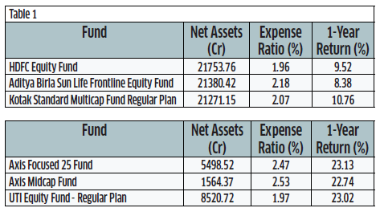

Even though these funds (Table 1) have the highest AUMs, the returns from these funds are moderate. Which goes to prove that it’s not necessary that the fund with higher AUM would offer you better returns every time. We have also seen the correlation between the AUM and one-year return to determine the relation of the AUM and one-year return. The result was negative, which suggests that when the AUM is higher, the returns may be negative and vice versa. The graph below clearly shows that there is no relation between AUM and one-year return.

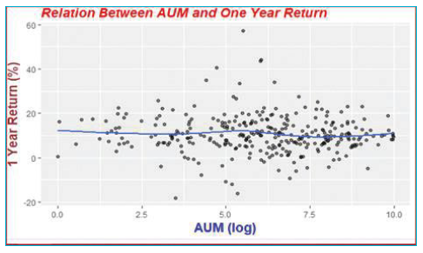

**Expense Ratio:** Expense of a fund is the second important thing that every investor looks at before investing. Many times, it has been assumed that schemes with lower expenses can give you higher returns. It is true in many cases that lower expenses increase the returns from the scheme, but it is not necessary that every time this will work. Statistically, there is a negative correlation between one-year return and expense ratio, however it works only in a shorter period. In the longer run, however, the correlation between the expense ratio and 5-year returns is positive. This means that, in the longer run, even schemes with higher expense ratios generate more returns than schemes with lower expense ratios. This is clearly evident in the graph below, which shows that initially the return declines with increase in expense ratio, but after a certain point, it increases. This increases the dilemma of the investor whether he should consider expense ratio while taking a decision as every investor aims for higher returns.

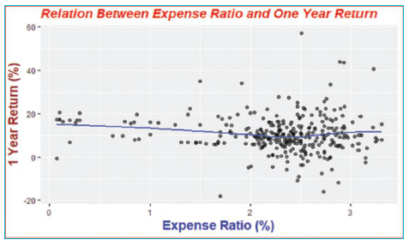

**Historical Returns:** Many a time, investors consider the past performance as one of the parameters for selection of the mutual fund. Historical returns do provide an insight into the fund’s past performance, but these are not an indicator for the future performance. Post-categorisation and reclassification of many of the schemes which have merged or have changed their investment philosophy, historical returns would be meaningless, so one needs to evaluate schemes with the existing portfolios.

**Portfolio turnover:** Portfolio turnover ratio indicates the frequency with which a fund's holdings has changed in the past one year. The buying and selling of the securities determine the portfolio turnover. It is positively correlated with the expense ratio. So, when the portfolio turnover ratio is high, the expense ratio is also high.

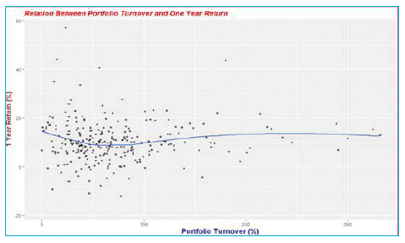

**Fund manager's tenure:** It is yet another aspect which investors looks at while investing in mutual funds. Fund managers tenure indicates his experience in managing that scheme. It is assumed that longer the period a manager handles a fund, higher would be the returns. But not in every case the fund manager with a longer tenure generates higher returns. We have analysed this statistically and could not find any relation. This is true for even three-year returns. So, even a fund manager with longer tenure does not provide any assurance about the future returns from the scheme as longer tenure does not guarantee better performance by the fund manager. Investors mistakenly tend to believe that if a fund manager has been managing the fund for many years, he will generate higher returns. All the above factors are directly or indirectly related to the portfolio of the scheme. The tenure of the fund manager may indicate the fund manager's abilities and management style and whether these have influenced the fund's returns. Investors prefer to look at these factors rather giving importance to the portfolio of the scheme. Below is the correlation matrix that shows the relation between all the factors. You can see that none of the factors are significantly positively corelated with one year and three year return. For example, the correlation coefficient between one-year return and market cap of the fund is mere 0.39, which means every increase 1 increase in market cap of a fund, one-year return increases by 0.39. Nevertheless, statistically we not find it significant. If these factors are not important than what drives the returns of the funds. It’s the portfolio of the MF schemes.

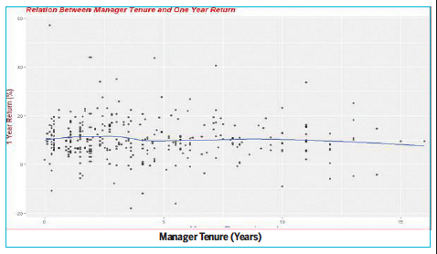

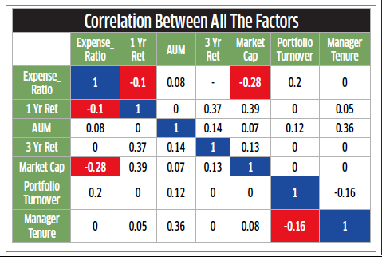

**The target NAV is a moving target. Therefore, Nothing less than portfolio, nothing more than portfolio.**

The portfolio of a scheme is the mix of securities from different asset classes where a fund manager invests the fund's corpus. It helps investors to gauge the fund’s performance. Portfolio can be the best way to evaluate the scheme in terms of its present and future performance. This is something which an investor usually ignores and runs behind the other aspects discussed above. So, the bottomline is that the portfolio is the key determinant for the scheme and its future returns. So, let us explore how portfolio can be a great tool to analyse the fund dynamically from the present and future perspectives.

**How portfolio helps you to evaluate the current performance of the scheme.** Portfolio of the scheme is the best guide for the investors. The first and foremost important aspect which an investor can easily notice while analysing the portfolio of the scheme is the concentration of the fund. The portfolio shows where the scheme has invested the most and on which sectors the fund manager is betting more, which can be a valuable guide to analyse the risk as well as the current performance of the fund. The second most important aspect which is a key to evaluate the equity mutual fund scheme is the valuation. One can determine the valuations of the scheme by its portfolio. The price-to-earnings (P/E) and price-to-book value (P/BV) are the two important valuation ratios. The P/E and P/BV ratios are considered the key reference points for analysing the performance and making an investment decision in the equity markets. Generally, the P/E of a stock suggests how much investors are willing to pay for one rupee of company's earnings. A higher P/E signifies higher return expectation, so these types of stocks are often considered as growth stocks. But P/E for mutual funds is the average of P/Es of all the stocks in proportion to their weightage in the portfolio. On the other hand, P/BV ratio is useful in comparing the current value given by the market as against the book value. A lower P/BV is considered as a sign of undervaluation, whereas a higher P/BV is considered as overvaluation. P/BV is also calculated like the P/E and is the weighted average of P/BV of the underlying securities. But still the question remains: how does one exactly measure the undervaluation and overvaluation of the scheme? One can consider the category average and benchmark's P/E and P/BV for evaluating the scheme's performance. The fund's P/E and P/BV can be used for comparison with the funds within the category or for comparing categories. For instance, if one is investing in a value fund, then investors need to make sure that the P/E should be lower than the other categories as these funds invest in securities that are undervalued. Further, the mid-cap schemes will have relatively higher ratios than the large-cap funds currently. The trailing valuations of the portfolio suggests the current positions of the holding.

**Determine future performance and how we ace it.**

We have seen above how a portfolio is useful in analysing the current performance and how it is an important aspect. Now, let us see how the portfolio of a fund can be used to forecast the future performance of the scheme. The portfolio of the scheme is made up of the securities which are evaluated independently too. So, it is possible that we can forecast the performance of these securities, which can then be further translated into the NAV. Therefore, we can analyse the securities independently to arrive at the potential upsides of the stocks and can come out with a target NAV in the upcoming period. So, one can see the future performance of the fund according to its constituent’s expected returns over a period. With the changing prices of the securities and changes in the portfolio every month, the target NAV is a moving target. Therefore, one needs to keep an eye on the portfolio constantly. This will help the investor to reap higher returns and even be able to time the mutual fund investment. For a common investor, it will be a tedious and next to impossible task to track these companies as there are more than 1200 companies that are being held by equity mutual funds. Analysing each company and predicting its price could be quite cumbersome and may not even help you if your target goes wrong. We at DSIJ, rank the equity funds using this methodology. According to us, the portfolio holdings are the key determinants of the future performance of the funds. So, we have deployed a unique method of ranking the equity funds with respect to their expected returns. Having a history of more than 32 years in equity research, we take advantage of our research strength and experience of understanding listed companies to ascertain the expected return on the underlying stocks of each equity fund. We evaluate the underlying portfolio of stocks of each fund and calculate their expected returns. This helps us to come out with expected returns of every equity fund. This enables us to be fund manager agnostic and without getting biased by the historical returns of the funds. This way, we are also able to rank the newly launched funds that are not rated by others due to their shorter duration of existence. Every day, we evaluate all the equity funds based on changed ratings of underlying stocks and price changes in the underlying asset allocations. Therefore, this list is quite dynamic and reflect the best return potential of the funds for the next one year. The only caveat being the rankings depends on the fund’s holdings and their prevailing share price. You can check current expected returns of each fund on our website http://www.dsij.in/ mutual-fund

**Proof of the pudding lies in eating it.**

At the end of February 2018, we have seen some of the ETFs and banking funds with higher return potential in our ranking system and are suggesting returns varying from 20-40%. Post that, in six months till now, these funds have offered returns ranging from 7-12% in the past six months. This despite all the ups and downs in the market. Still, with the changing stock prices of the portfolio constituents, the returns and expected returns will keep changing going ahead. The above analysis clearly shows that instead of looking at various parameters, look at the constituents of the portfolio, which is the creator of all these ratios and other aspects. We can see that the scheme does not perform based on the expense ratio, AUM, or any other aspect, but the returns are determined by the securities the fund is invested in, that is, the portfolio. So, ultimately, the portfolio of the scheme is the kingmaker for the investors. Hence, while investing, you need to study the scheme's portfolio which can give you a better sense of its future returns.

